Indirect Questions
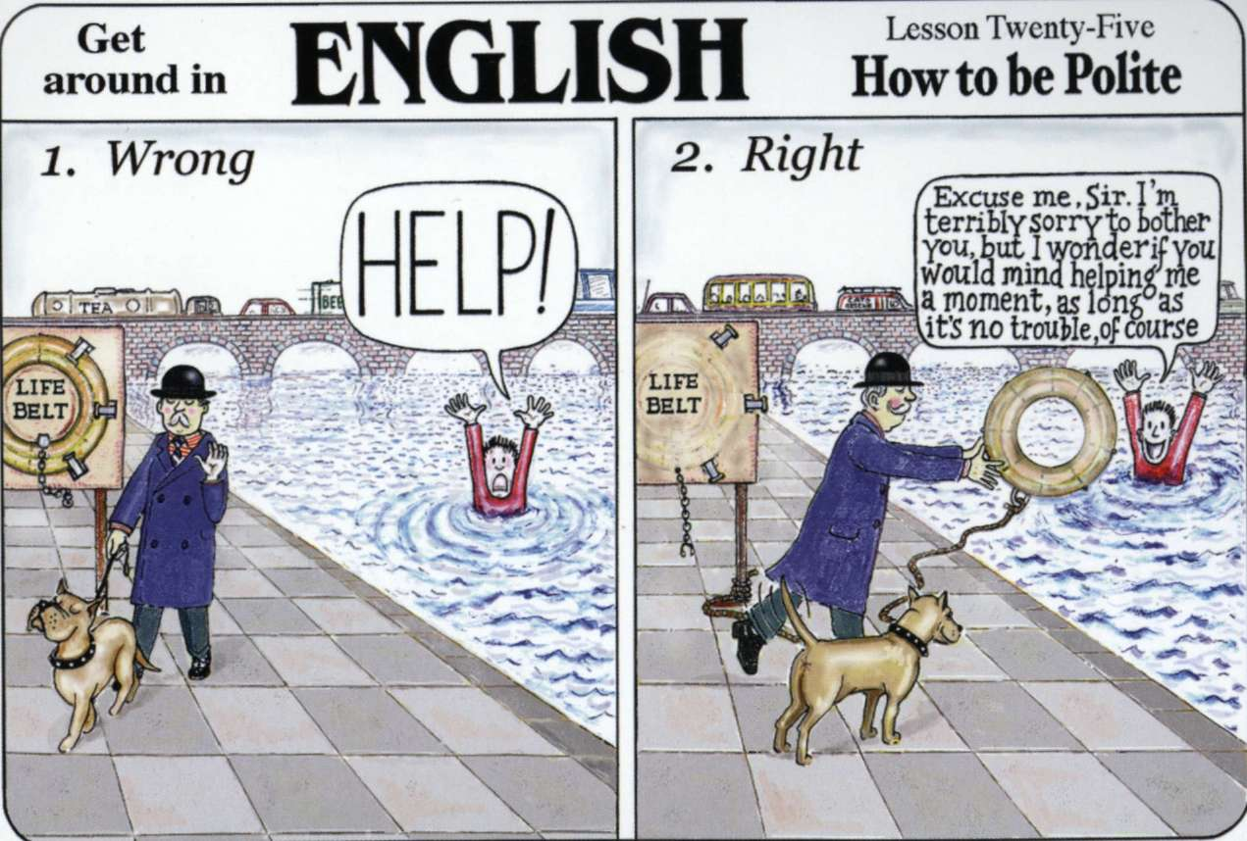
Discuss:
Look at the cartoon. Do you think that this is true of British people? Is it the same or different in your country and in your language?

Imagine that you are looking for a new housemate and you want to interview them to find out if they are a good match for you.
Work with a partner and come up with a list of 10 questions that you would ask. For example:
- How old are you?
- Where did you live before?
- Do you have any bad habits?
- Have you lived with other people before?

- _______________________________
- _______________________________
- _______________________________
- _______________________________
- _______________________________
- _______________________________
- _______________________________
- _______________________________
- _______________________________
- _______________________________
Once you are sure that your direct questions are correct, pick up the cards, and change the questions so that each one includes one of the phrases on the cards. You will need to change the word order. Fill in the table on page 3. For example:
- I was wondering how old you are.
- I’d like to know where you lived before.
- Could you tell me if you have any bad habits?
- Can I ask you if you have lived with other people before?
Direct Question | Indirect Question
Information questions (using Question Words)
QW + aux + sub + main verb | Phrase + QW + sub + aux (not do) + main verb
How old are you? | Can you tell me how old you are?
Where do you come from | Can you tell me where you come from?
Why are you moving? | Would you mind telling me why you are moving?
When will you move? | I’d like to know when you will move.
Yes/No Questions
Aux + sub + verb | Phrase + if/whether + sub + aux + main verb
Do you have any bad habits? | I was wondering if you have any bad habits?
Were you evicted? | I was wondering whether you were evicted
Have you been living here long? | Can I ask if you have been living here long?
Will you move soon? | Can I ask whether you will move soon?

Further Practice
Put the cards in the correct order to make indirect questions.
Try these indirect questions for more practice.

- Does she speak Greek? - I will ask her if she speaks Greek.
- Where is Joe? - I have no idea where Joe is.
- Whose car is it? - I'm not quite sure whose car it is
- Is this the right train? - Let's ask someone if this is the right train.
- How much is this scarf? - Why do you want to know how much this scarf is?
Work in a pair/group, you are going to interview each other using your questions from earlier and decide who would make a good housemate.
Write answers in the table below. When answering an indirect question, you can answer in the same way as a direct question.
Question | Person 1 | Person 2
Can I ask you if you have children?
I would like to know if you smoke.
Have you got any idea if you sleepwalk?
I’m not sure where you grew up.
Can I ask you if you listen to loud music?
Would you mind telling me where you are originally from?
Would you mind telling me if you snore while you are sleeping?
Do you remember what time you came back yesterday?
Do you happen to know what the weather will be next week?
Have you got any idea how long you are going to stay in this country?
Could you tell me what you do for a living?
I was wondering when you moved.
Can you tell me when you moved?
I wonder where you work.
I was wondering when you stopped working.

Who would you choose to be your housemate?
Bonus points if you can share the interview using reported speech!

